To set up angular project, node has to be set up first. Once node runtime is setup, with NPM(Node Package Manager) we can download and install angular related modules from registry.

**Steps to setup Node Environment – LTS 10.15.1 (npm 6.4.1)**

1. Download Node msi installer for respective platform from <https://nodejs.org/en/download/>

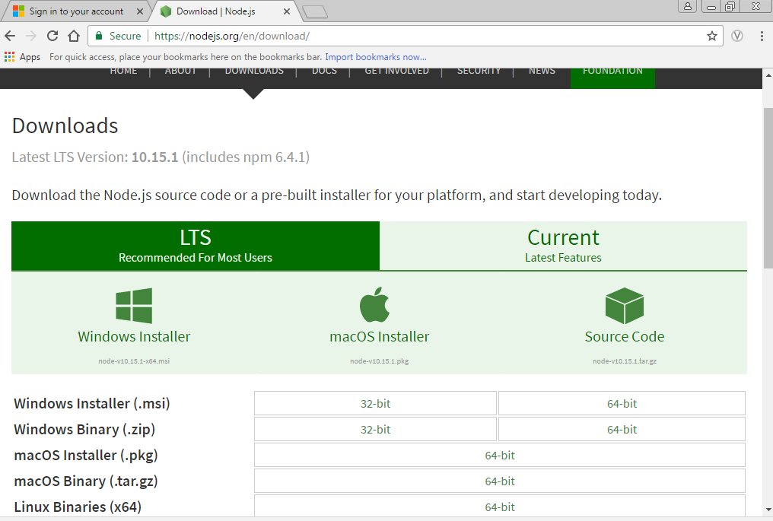

1. Run the downloaded node msi installer

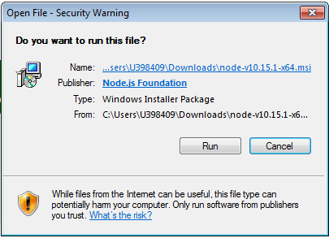

1. Click next on the Node.js setup installer welcome screen.

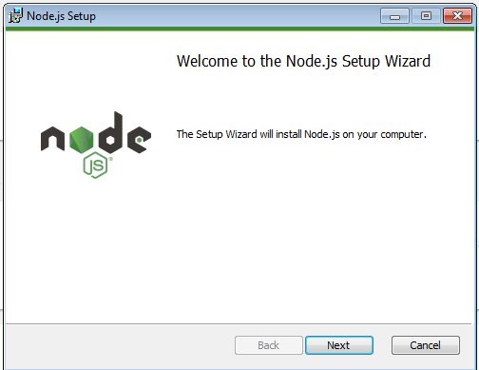

1. Check the license agreement check box and click next.

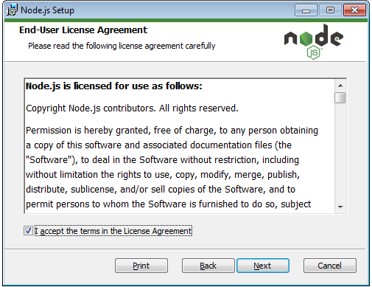

1. Click next, after destination folder selection, where you want node to be installed, by clicking on change button. By default, it gets installed in program files.

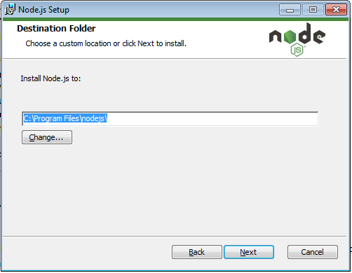

1. Click next on the custom setup screen.

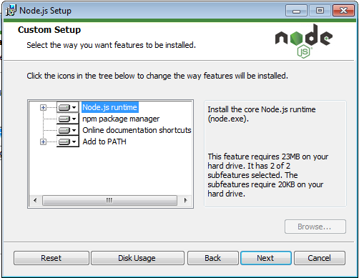

1. Click on install

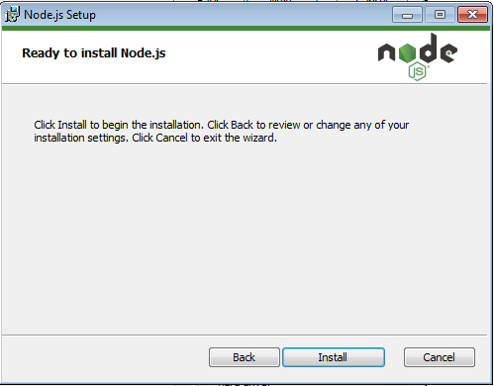

1. Click on finish button.

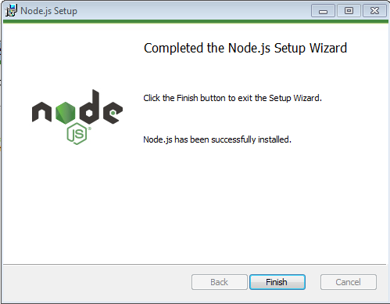

1. To validate node installation, type node in the command prompt. The node REPL should start running.

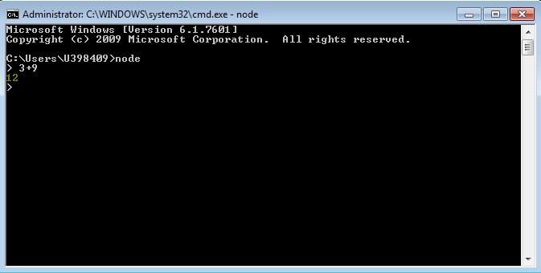

10 NPM version can be checked via npm –v command.

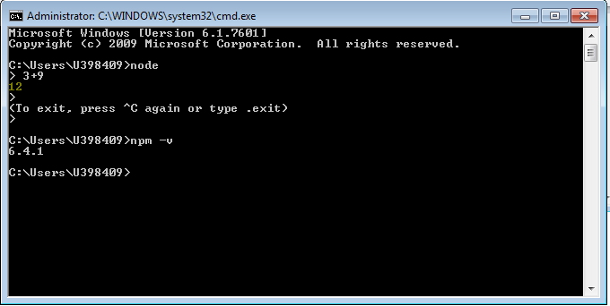

NPM Proxy configuration:

Once node is installed, the proxy configuration has to be done in order to install modules from NPM.

If .npmrc file is already present at C:\Users\<*your lan id*>, make sure that it has following text in it.

**strict-ssl=false**

**registry=http://registry.npmjs.org/**

**https-proxy=http://bcilproxy.hcscint.net:8080/**

**proxy=http://bcilproxy.hcscint.net:8080**

If .npmrc file is not present at C:\Users\<*your lan id*>, please execute below command to create it and replace the content with above lines.

**npm config set registry xxx**



**Angular client installation:**

The Angular CLI is a tool to initialize, develop, scaffold and maintain Angular applications.

**Steps to setup Angular Client**

1. Run command **npm I –g @angular/cli** from command prompt.

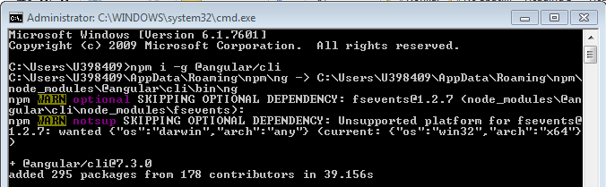

1. Run command **ng new *projectname***  to scaffold new angular project.

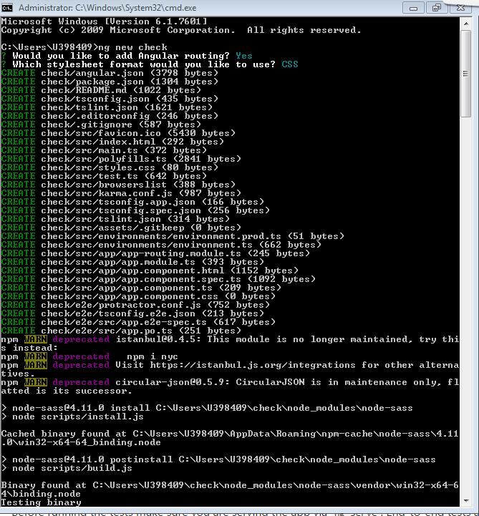

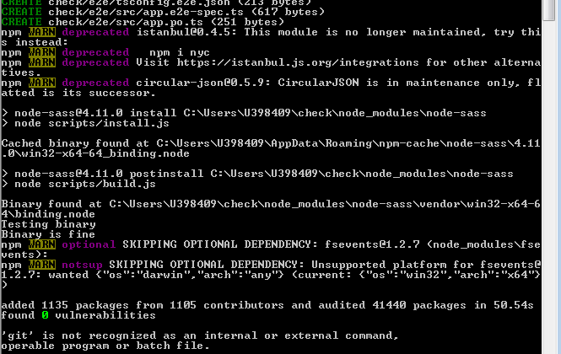

1. Run command **ng serve** inside project root folder to run the project.

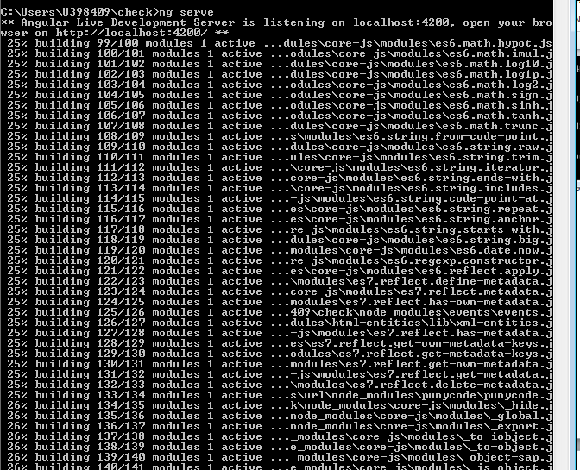

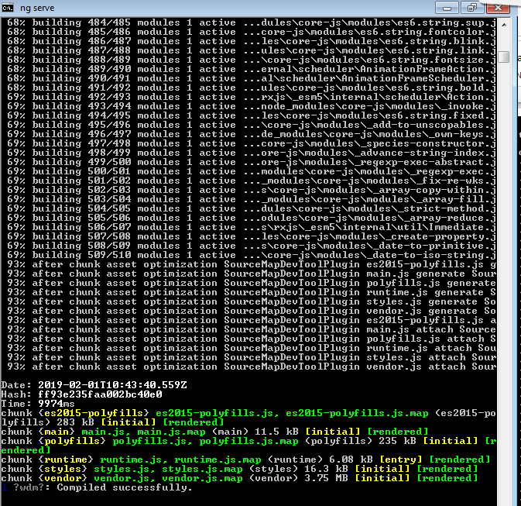

Additional ng commands can be referred here

<https://angular.io/cli>